Scenario 5 – The Pit

Number of players: 2

Necessary Components: Basic game

Victory Conditions: 5 VP

History

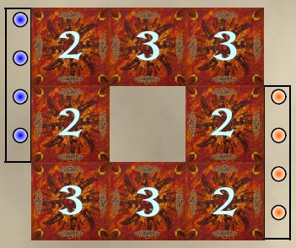
At the time of the construction of this Dungeon, the workmen discovered a pit so black and infinite that even Archmage could not determine the exact depth of it. Work was already quite advanced and Gnomes had to use ingenuity and technique to manage to offer a new Dungeon to their Master.

Plan of the Dungeon

All the rooms are placed randomly and face hidden so as to leave an empty zone in the centre as indicated on the plan. This central hollow represents the Pit.

Each player places his pawns as described in the basic Rules.

Special Rules

The play proceeds exactly like a normal game, only the presence of the Pit which can disturb the usual strategies. The Pit is passable only by the flying characters for 2 AP. The first AP is spent to enter the Pit, the second to leave there. The room of exit is chosen by the player among all those valid located at the immediate periphery of the Pit.

Labyrinth created by Gwénaël Book (yaourth@octopedia.net) - ©10-2004

