Scenario 3 – Moving Stones

Number of players: 2
Necessary expansions: Basic game

Victory Conditions: 5 VP

History

The Labyrinth of the Moving Stones built by Aktùn Shläkbeük.

This Gnome architect discovered at the end of his life, a means of making the rooms slide by improving the techniques usually employed to make them turn.

He used all his knowledge to create his ultimate realisation, and then disappeared mysteriously with his secrets.

The Gnomic legend says that it is his cursed heart which actuates the mechanisms of the Labyrinth.

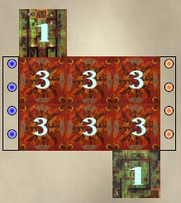
Dungeon Plan

The rooms n°1 (green) are placed face up in random facing.

The remaining rooms are placed face down.

Each player places his pawns as described in the basic rules.

The pawns located in the known rooms are revealed at the same time as the Starting Teams and are placed on the box chosen by the player.

Special rules

The two rooms n°1 located on both sides Labyrinth are equipped with the mechanism of Shläkbeük.

That means that they can swivel but also slide along the adjacent rooms. A character controlling the rotation wheel of the one of the rooms can, for 1 AP, to move the room along a position.

Automatically, the opposite room is moved in opposite direction of the same number of positions.

Example

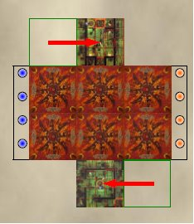
The player who controls the room n°1 the high one spends 1 AP to move it of a position towards the line.

Automatically, the room n°1 of bottom slips of a position towards the left. It is possible to spend more AP’s to move a room several positions and to even make a room return in the other direction.

The only constraint being that the two rooms function together and must always move at the same time.

Dungeon created by Gwénaël Bouquin (yaourth@octopedia.net) - ©10-2004

