Star Twister
Chris Boelinger (translation: Tony Crider)

Story
Tired of the same old linear games on a rectangular board? These rules provide a way to change the structure of the board with only the base game and some new starting lines that you can print for yourself.

Number of Players
2

Required Expansions
1
1
2
2
2
2
1
1

Only the basic game is required for this scenario.

Board Layout
All the rooms are mixed and placed face down as usual per the layout to the right.

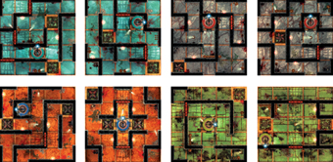

The Mini-Starting Lines
Originally, the mini-starting lines were tested for a 5/6 player game. This expansion might one day exist, but in the meantime, why not use some of its elements now to vary the structure of your Dungeon Twister games?

To play this scenario, you should print and cut out the mini-starting lines found on the last page and construct the board as indicated above.

Starting Pieces
Each player begins the game with the 8 characters and 6 objects included in the basic game. Each player must place 4 characters face down on each of the two mini-starting lines that belong to him. The characters stay hidden until game setup has been completed.

Game Setup
Game setup is carried out as usual except that each player only has to place his 6 objects. When placing your tokens, you must observe the limits on the maximum number that may be placed on a room as shown above.

When all of the objects have been placed, the characters on all four starting lines are revealed and play begins.

Victory Points
You gain a VP for each character that leaves the labyrinth by way of either of your opponent’s starting lines.

You gain a VP for each of your opponent’s characters that you eliminate.

Victory Conditions
This scenario ends when a player has attained 5 or more VP.
