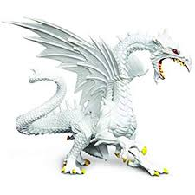  Speedster  A dragon can  move 4 spaces instead of 3 |  | Fighter  +2 on an attack roll
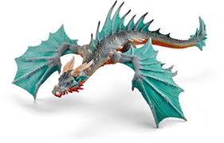  Sneaker  +2 on a steal roll |  | 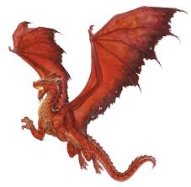  Destroyer  +2 on a destroy roll
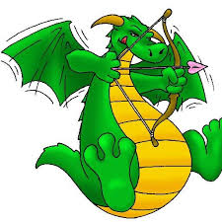  Jumper  Place dragon adjacent  to any of its claims |  | 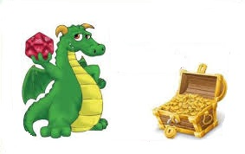  Robber  Pick a dragon to lose up to 3 coin  Increase the thief’s treasure chest by those coin
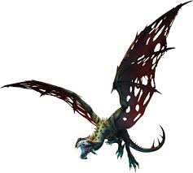  Horror  Place a dragon adjacent to its cavern |  | 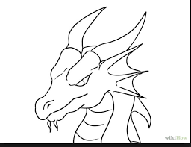  Watcher  Prevent a thief from  stealing from a dragon
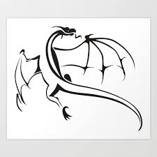  Orienteer  Move a dragon 3 spaces |  | Peacemaker  Before an attack  Place a dragon  adjacent to its cavern
Vigor  A dragon gains 1 additional action this round |  | 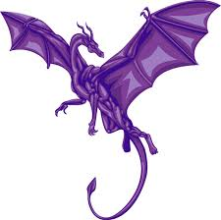  Sheriff  A dragon gains +1 coin  from all successful town tributes
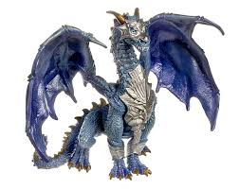  Leader  Prevent a settlement  from being claimed |  | 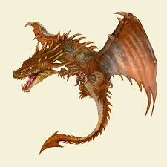  Defender  -2 on an attack roll
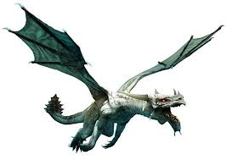  Copier  Copy a card power  currently played this round |  | 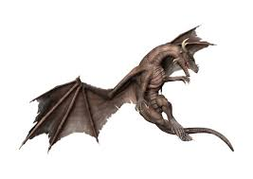  Trickster  +/- 2 on any roll

